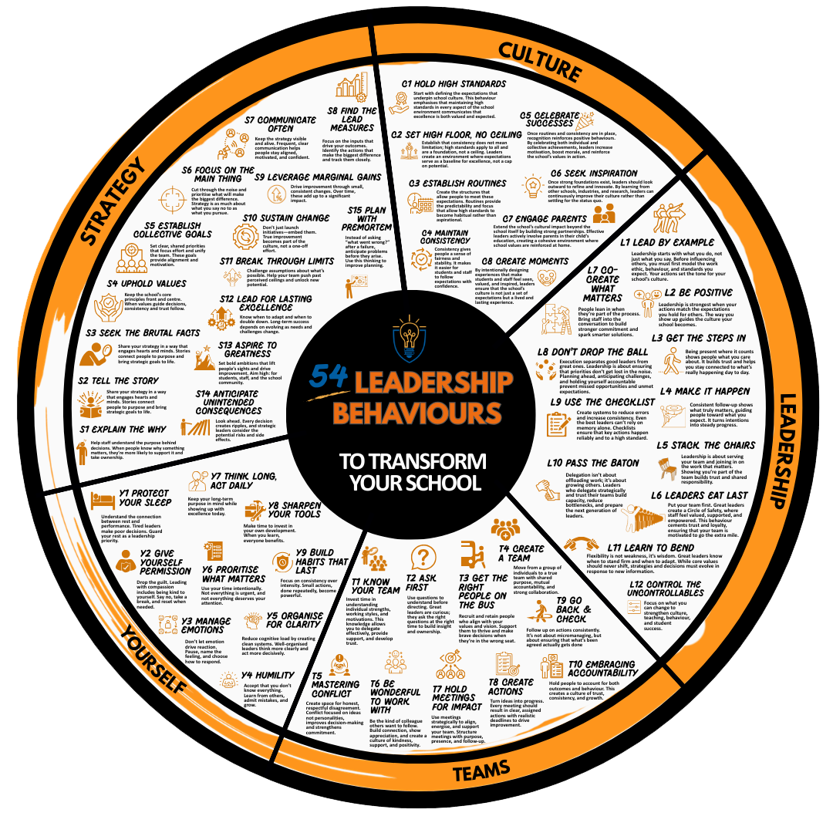

C1: Hold High Standards


Example toolkit

Role: Head of Department
Area
I am focusing on classroom routines and expectations within the English Department, with particular attention to punctuality to lessons, student readiness to learn, and adherence to presentation standards in books.
Stated Standard
All students arrive before the second bell and begin the Do Now task immediately. Exercise books follow the agreed presentation policy, including underlined titles, correct dates, and use of blue or black pens. I model these standards consistently and correct any drift immediately. Every classroom displays the departmental Ready to Learn poster and I use identical language to reinforce it.
Evidence Tracker
Evidence This Week | Drift Noted | Immediate Action | Owner | Review Date
Learning walks showed four classes with strong start routines; one group entered late twice. | Year 9B entering late and inconsistent Do Now start. | I met with the class to reset expectations and introduced a visual countdown timer. | Ms Smith | Next Monday
Book looks showed improvement in 8 out of 9 classes. One teacher using green pen instead of blue. | Minor presentation inconsistency. | I will give a department meeting reminder and share example pages. | HoD | Friday
Two new displays in corridors aligned with policy. | None | Celebrate with photo share in staff briefing. | HoD | Friday
Peer observation feedback: positive modelling of routines. | No drift observed. | Continue drop-ins to sustain consistency. | SLT link | Next fortnight
Reflection Prompts
The key standard slipping slightly is punctuality to lessons after break for Year 9. The cause appears to be corridor congestion rather than staff enforcement. I will coordinate with the duty staff to improve movement. Teachers are modelling expectations well; the drift occurs with a small group of students testing boundaries. Expectations may need re-teaching at the year-group level, not just within English. Positive recognition of improvement will help sustain consistency so that I will celebrate classes with 100% punctuality in next week’s assembly. Overall, the standards are holding well across the department because they are explicit, observable, and frequently reinforced. The evidence tracker ensures that I act immediately when drift appears, rather than waiting for patterns to form.

Toolkit

Holding high standards requires leaders to define what “good looks like,” check it relentlessly, and act immediately on any drift. This tool helps leaders identify the key areas of school life where standards must be upheld, make those standards explicit, and track whether they are being maintained over time.
Area
Which aspect of school life are you focusing on (e.g. uniform, corridors, classrooms, displays, work scrutiny)?

Stated Standard
What is the precise, observable expectation you want everyone to meet?

Evidence Tracker
Evidence This Week | Drift Noted | Immediate Action | Owner | Review Date
Reflection Prompts
Which standards are slipping and why? Are leaders modelling the same standards they expect of others? Where do expectations need re-teaching rather than simply re-stating? Are successes being celebrated as clearly as infractions are corrected?

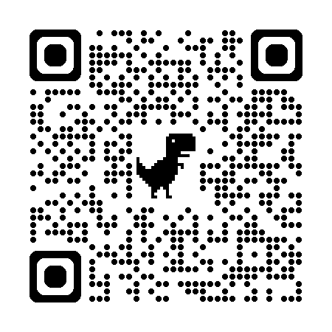
Coach and Practice
This behaviour develops a leader’s ability to make high expectations visible, consistent, and non-negotiable in daily practice.
Behaviour focus
Helping leaders ensure that everyone understands and upholds shared standards of behaviour, work, and conduct.
Purpose
To create clarity and consistency across teams by ensuring expectations are explicit, modelled, and reinforced every day.
Action Steps | Key Questions | Practice
Define what high standards look like. | What does excellent look like for this routine, behaviour, or piece of work? | Ask the leader to identify one area (e.g. uniform, punctuality, or presentation) and write a clear description of what meeting the standard looks like. Rehearse explaining it to staff or students in one sentence.
Make standards visible. | How can you make these expectations impossible to miss? | Practise scripting a short briefing or corridor conversation that reinforces standards using consistent, precise language.
Model and reinforce consistently. | What does your behaviour teach others about what matters? | Practise a scenario where expectations have slipped slightly. Practise calmly resetting them without frustration.
Recognise and celebrate adherence. | How will you highlight when standards are met? | Ask the leader to plan one visible recognition this week, such as praising a class or colleague who consistently meets expectations.

Practice Script and Feedback

Updated Practice Script

